# Instructions

1.Pre-requirements

MySQL 5.6

jdk1.8.0_291

IntelliJ IDEA 2020.1.3

2.Explanations

In flat file, I used **mysql database** to store the created categories and products’ tables.

In controller layer, I created a CategoryController.java to return the category list in Json format, and Product.java to return a list of products, a list of filtered products by category and a list of sorted products by name researching.

In Service layer, some methods are implemented can be invoked from the controller layer. In Dao layer, two ways to interact with database, one is the hibernate annotations, for example, getProductById(). And the other one is that getProduct()from ProductDao.xml.

Speaking of the web pages, I used javascript, css and bootstrap, mainly, get, post and ajax methods to meet the test requirements.

5.How to run it

I used Idea to create a springboot program, first, please **import the tables** into database.

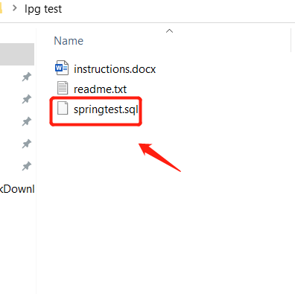

Then import the project into IDEA, and run **project** and then run it successfully.

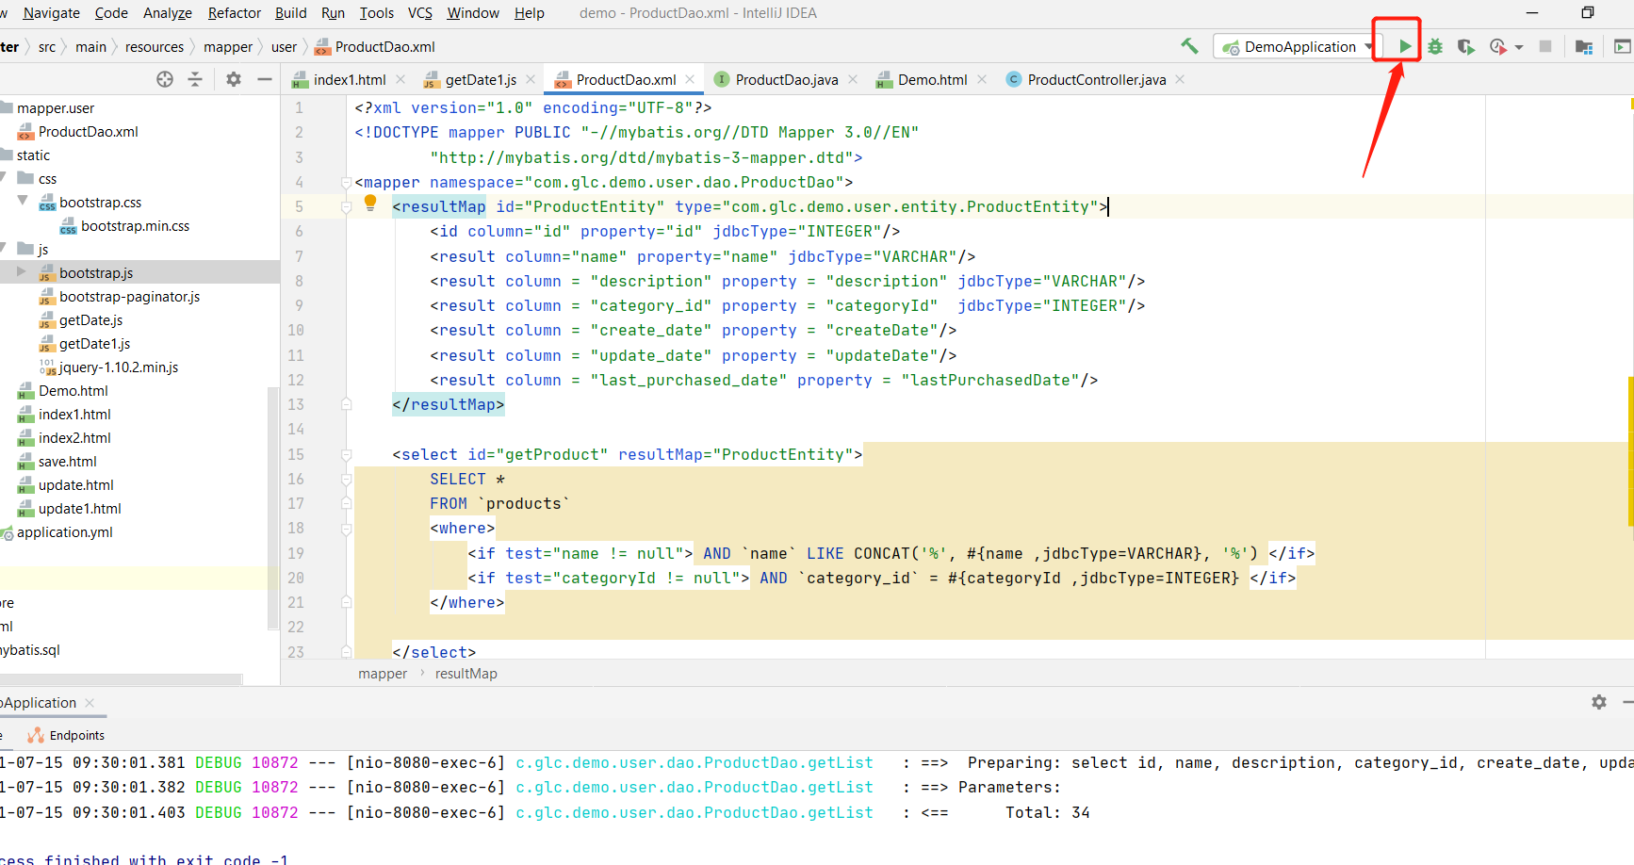

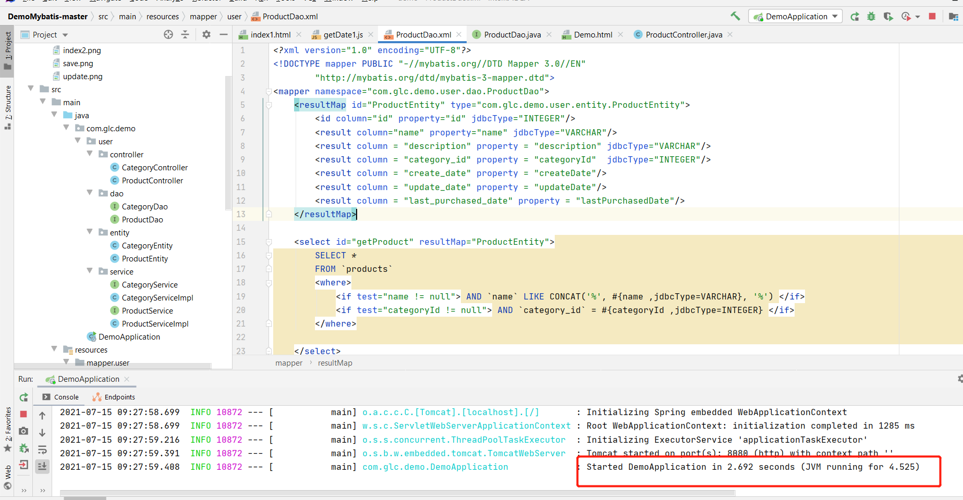

Then open a browser, and input “[localhost:8080/index1.html](http://localhost:8080/index1.html)”, we will see the product information. As a user, ,we can filter by Category and sort the products by Name. And we see a list of the products in a UI. Here, I don’t know what is the difference between ‘t to see all products’ and ‘e to list the products in a UI’, so here I just do what I can do.

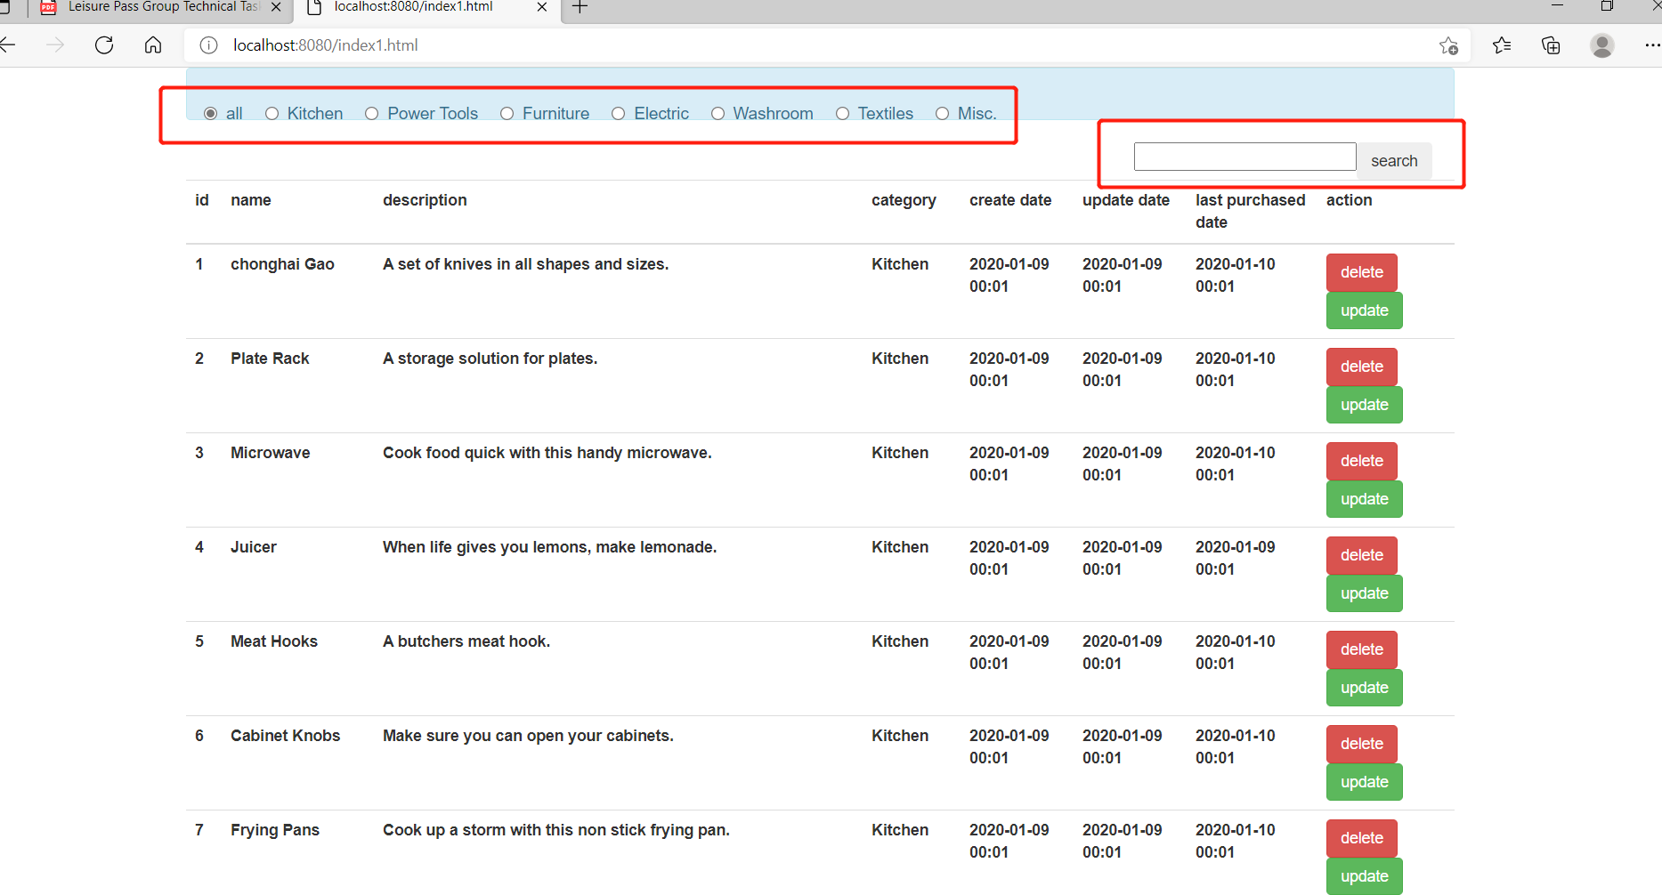

I tried to complete all functions like delete and update, but the time is limited.